# Grasshopper Resurvey: Phenological responses to climate change (Answer Key)

## [Link to the visualization](https://huckley.shinyapps.io/grasshoppers/)

## [Link to TrEnCh-Ed](https://trench-ed.github.io/#)

## Objectives

* Understand how temperature influences insect development rate.
* Use this understanding to examine shifts in seasonal timing (phenology) in response to cool and warm seasons.

## Core concepts -- *BioCore*

* Ecology & Evolutionary Biology: Evolution
* Ecology & Evolutionary Biology: Information Flow
* Ecology & Evolutionary Biology: Systems

## Instructions

First, read through the Grasshopper Resurvey introduction in the visualization. This will give you the required background information for these questions.

### Part A: Exploring Development Index Data

In this first exercise, you can generate figures that all have the same general structure. On the y-axis, you’ll see values for development index. On the x-axis, you can select between Season GDDs or Day of Year (in Day of Year units, Jan 1=1, and Dec 31=365). Finally, you can select one or more grasshopper species and one or more sites (elevations) to plot. The resulting lines will be in the shape of an upward trajectory that eventually levels off. Each line represents one population of grasshoppers (one species living at a particular elevation in a particular year). The line slopes upwards because the population as a whole matures over the course of the season, so its development index increases. Finally, when all individuals are adults, the line levels out. Dashed lines represent historical data and solid lines represent resurvey data, while bluer colors indicate cooler years and redder colors indicate warmer years.

* 1. For this question, look at all of the species plots
     1. What is each graph showing?

Each graph is showing the development index of a species of grasshoppers over a season at different elevation levels.

* + 1. What trends and patterns are you noticing for each species?

The species at high elevations have a shorter growing season, therefore their graphs are condensed to the middle of the summer season compared to those at low altitudes which are able to start growing earlier and persist activity later in the season. The only populations to never reach a development index of 6 were at the highest elevation.

* + 1. In general, how does phenology differ between cool and warm years?

Generally, warmer years allow the population to begin development earlier in the year and reach maturity earlier.

* + 1. How does phenology differ between low and high elevations?

The grasshoppers at higher elevations begin to develop later in the season.

* 1. Select the Aeropedellus clavatus to plot.
     1. How does phenology differ between historic and resurvey years for A. clavatus? (Hint: The closer a line is to the left of the panel, the earlier in the season development begins, and vice versa.)

Aeropedellus clavatus is beginning to develop (exit its diapause) earlier in the season in the resurvey years compared to the historic years.

* + 1. Why might this be?

A potential cause of this earlier start is the increased mean season GDDs which are higher in the resurvey years compared to the historic years.

* 1. Next, select just the Melanoplus sanguinipes.
     1. How does phenology differ for high vs. low-elevation populations of M. sanguinipes? (Hint: The steeper the line, the faster development occurs.)

Low elevation populations develop slower than the high elevation populations.

* + 1. Why might this be?

A potential cause of this slower development is that, while there are GDDs earlier in the year, they are for short periods of time during the day and thus the grasshoppers develop slower. This can be compared to high-elevation populations which are limited in emergence by the melting of the snow, and their emergence and growth begins when the growing temperature is maintained for longer periods of the day.

* 1. For this question, just look at the time periods of 2007 and 2010.

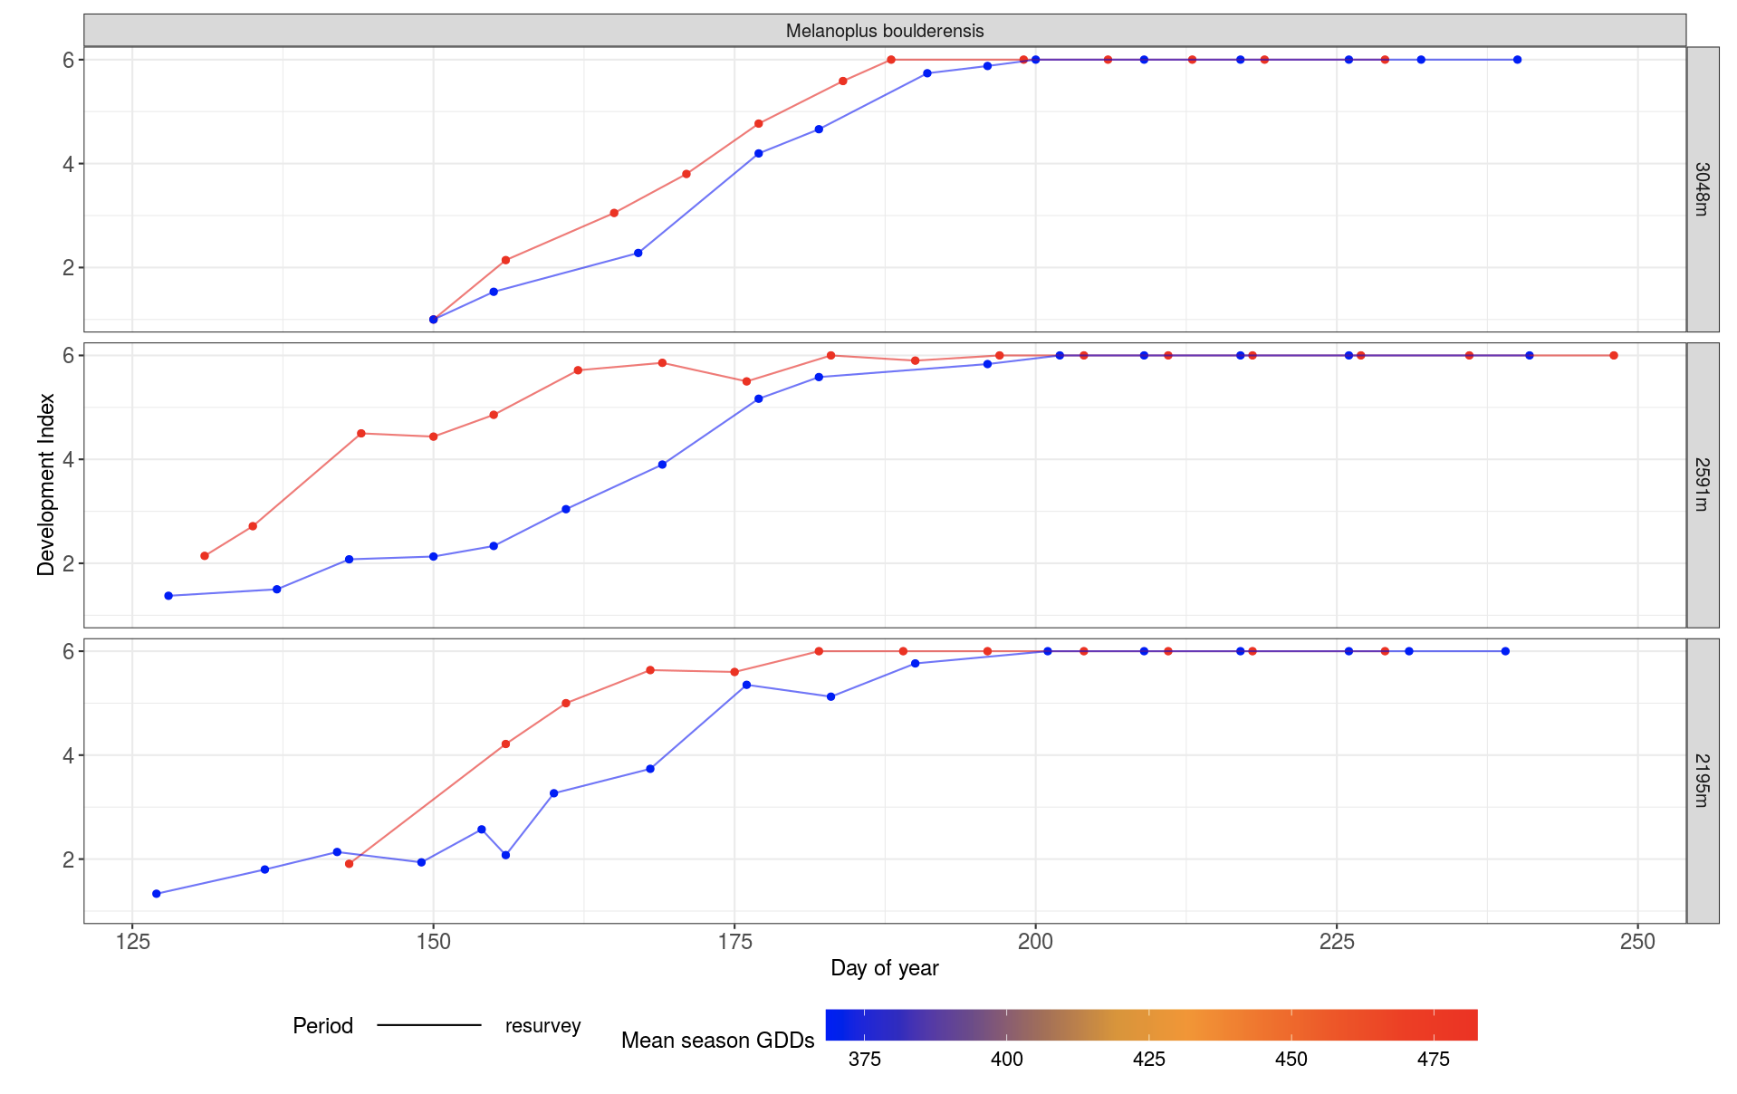

2007 = red; 2010 = blue

* + 1. How does phenology for M. boulderensis differ in 2010 vs. 2007?

The 2007 populations developed earlier than the 2010 populations.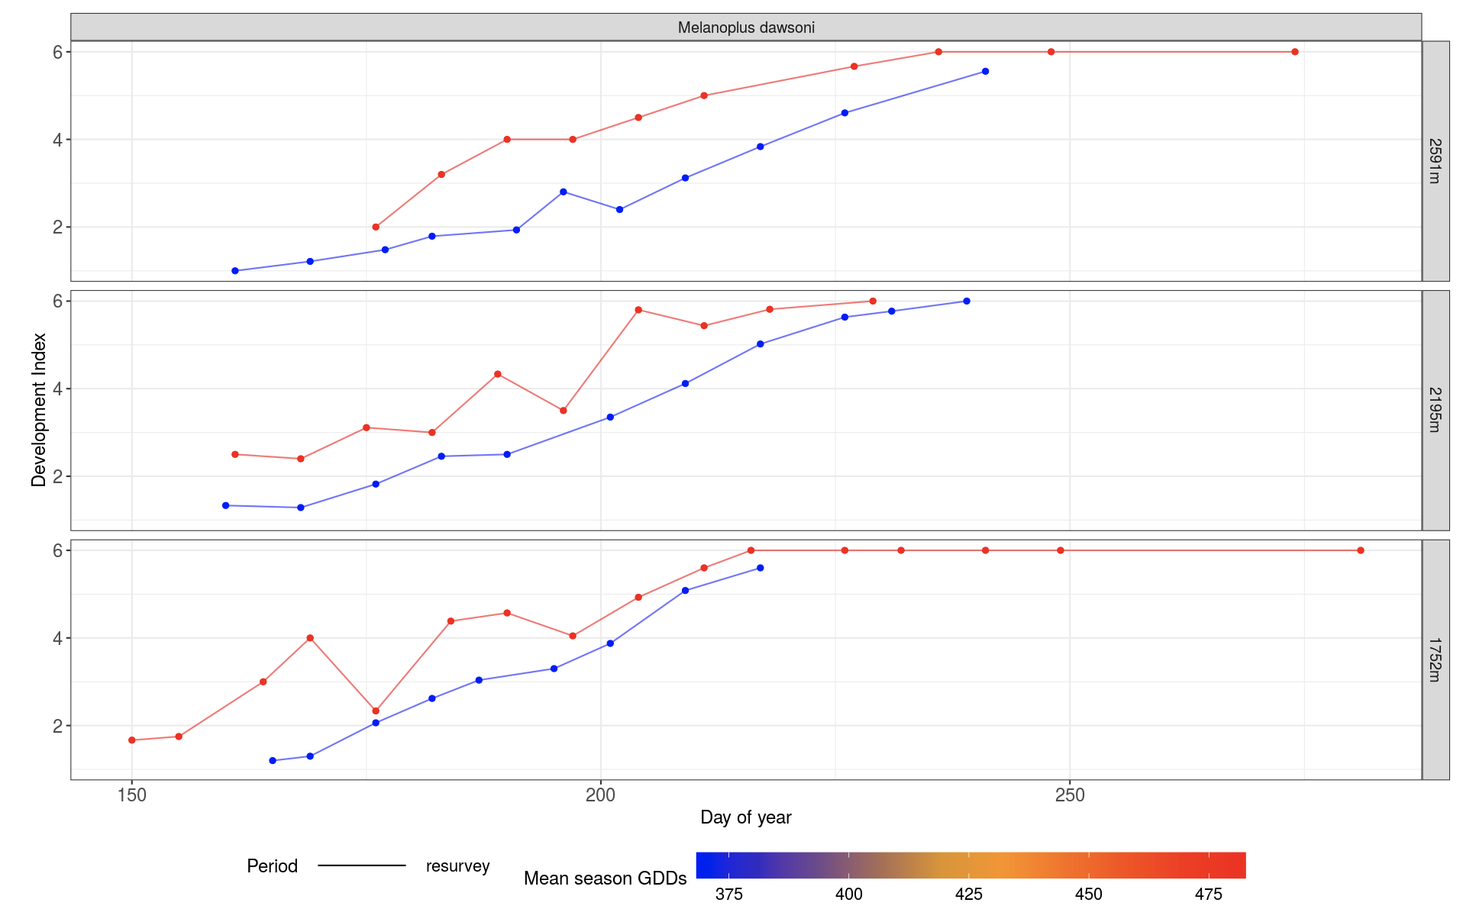

2007 = red; 2010 = blue

* + 1. What about M. dawsoni?

Likewise, the 2007 populations developed earlier than the 2010 populations.

* + 1. Why might this be?

This may be due to 2007 having a higher mean season GDDs than 2010.

#### 

### Part B: Exploring relationships between time, growing degree days, and grasshopper phenology

In the second exercise, you can again select one or more grasshopper species and one or more sites (elevations) to plot. Two kinds of figures will be generated: On the left, you’ll see data showing which day of the year your chosen population reached adulthood in relation to how warm the growing season was that year. For example, a data point located at 200 on the x-axis and 180 on the y-axis reflects a population that reached adulthood on day 180 in a year when the summer season had 200 growing degree days.

On the right, you’ll see data showing how much accumulated heat your chosen population had experienced before reaching adulthood, again in relation to how warm the growing season was that year. For example, a data point located at 300 on the x-axis and 200 on the y-axis reflects a population that reached adulthood after it had experienced 200 growing degree days, in a year when the summer season had 300 growing degree days. A relatively horizontal line suggests that the population tended to reach adulthood after experiencing the same amount of accumulated heat, no matter how warm or cool the season was.

1. Plot the data for all species at site 2591m.

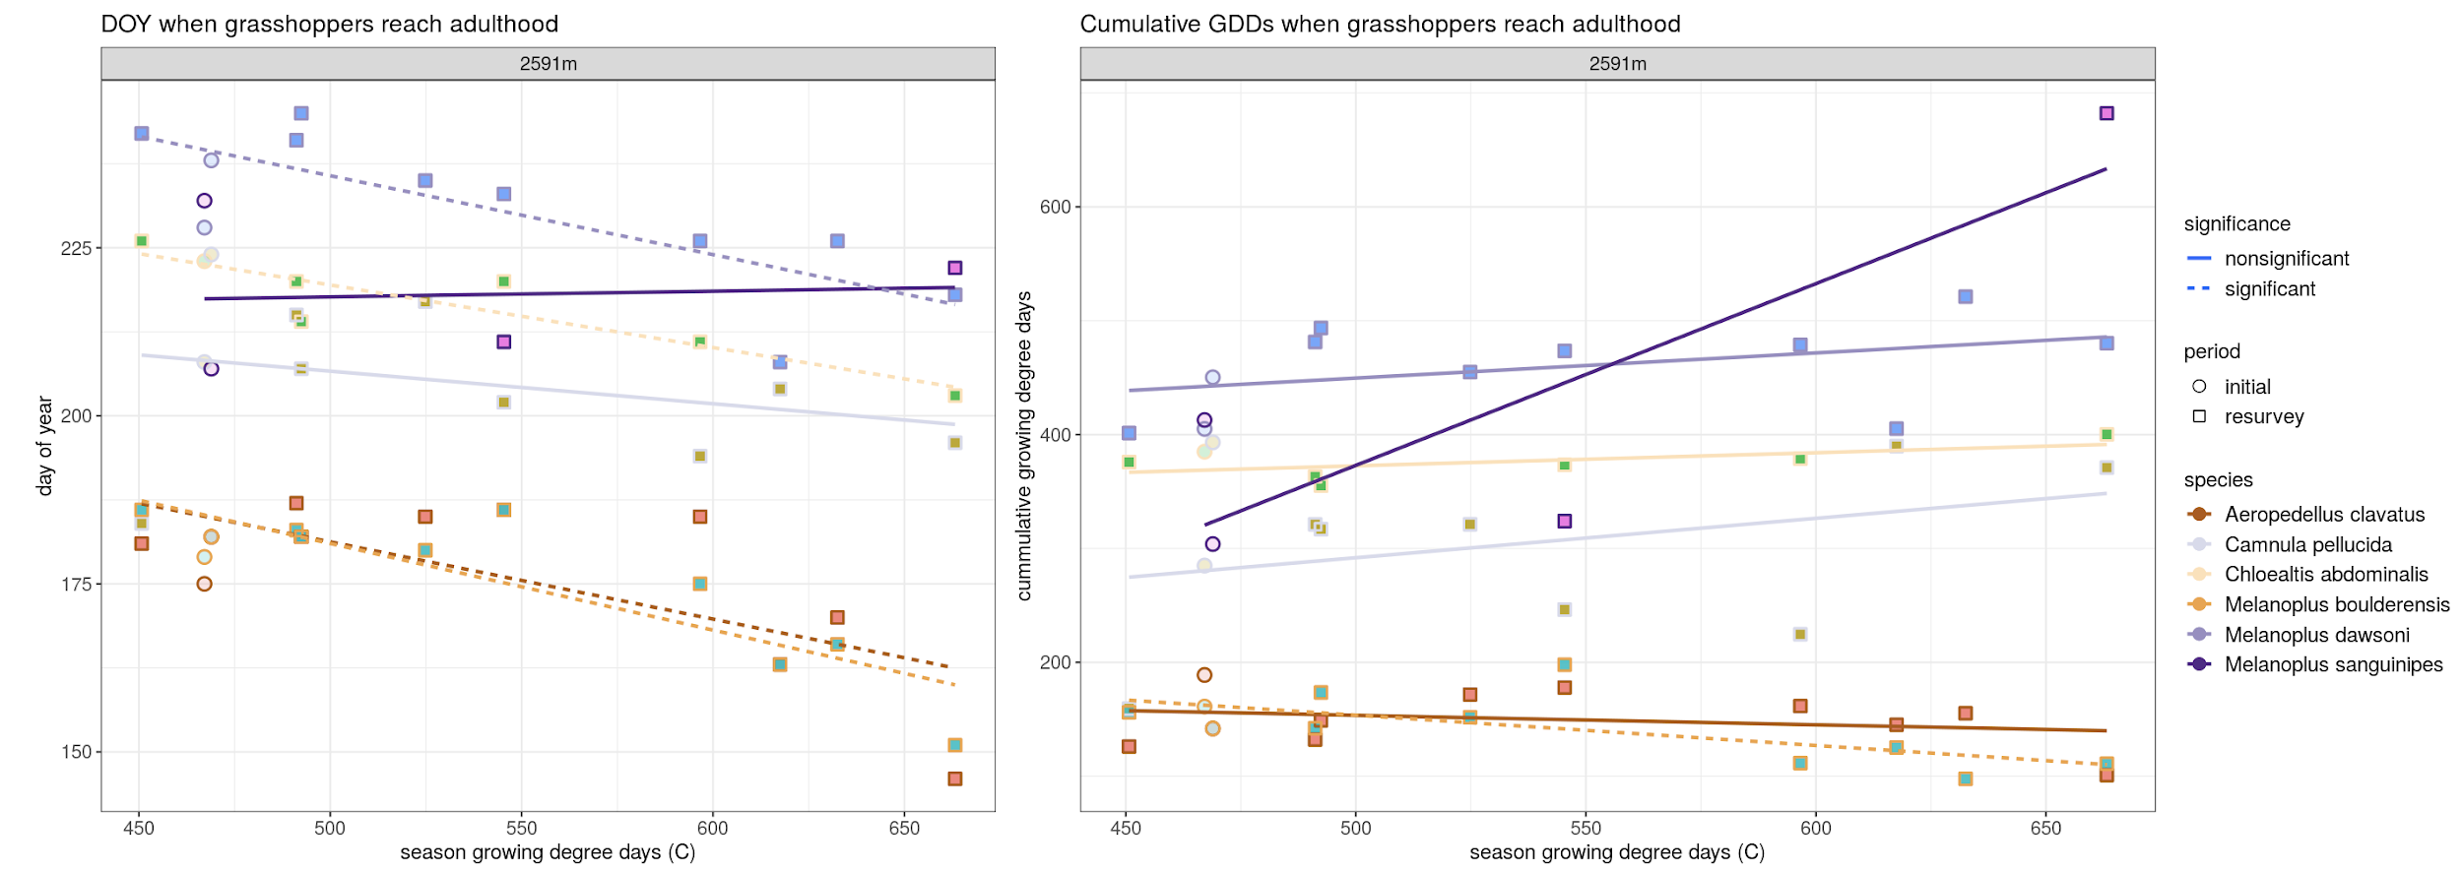

* 1. In cool vs. warm years, do the dates at which grasshoppers reach adulthood change?

In warm years, the grasshoppers reach adulthood earlier.

* 1. Does the amount of accumulated heat they experience change before reaching adulthood?

For some species, the amount of accumulated heat they experience increases. For others, the amount of accumulated heat they experience decreases.

* 1. Is this different for early vs. late-season grasshoppers (see the **Grasshopper traits** table in the reading above)?

Yes, early-season grasshoppers experience less accumulated heat. Late season grasshoppers experience more accumulated heat.

1. Plot the data for the species *Melanoplus dawsoni*.

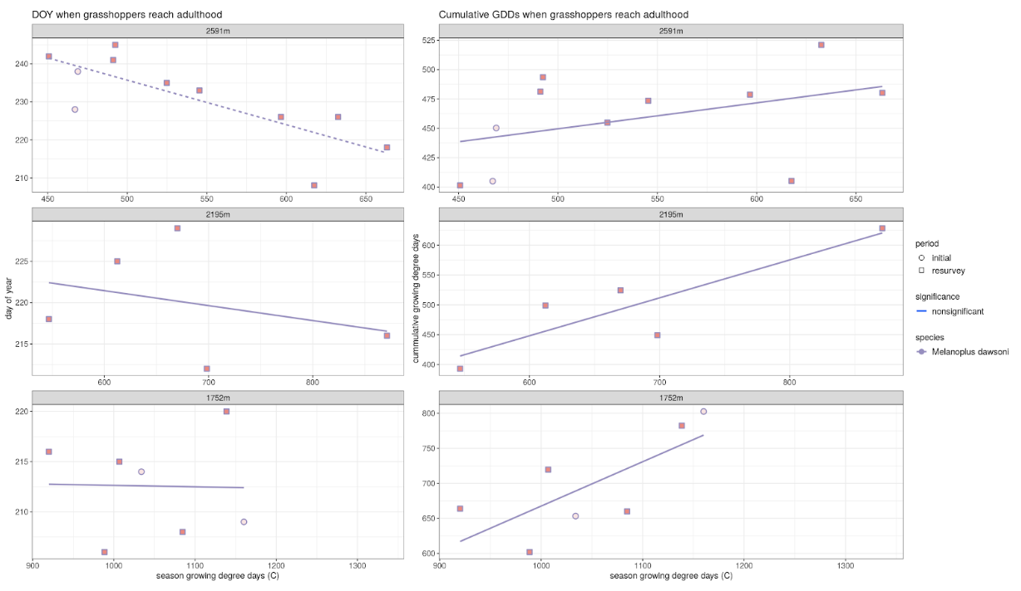

* 1. How does the date at which *M. dawsoni* reaches adulthood change with seasonal warmth?

Generally, the date at which it reaches adulthood decreases with seasonal warmth.

* 1. Is this different at low vs. high elevations? Explain why this might be.

This is much more pronounced at high elevations.

1. How does the amount of accumulated heat *M. dawsoni* experiences before reaching adulthood change with seasonal warmth?

The amount of accumulated heat it experiences increases with seasonal warmth.

* 1. Is this different for early vs. late-season grasshoppers?

Early-season grasshoppers have limited change in accumulated heat with seasonal warmth. Late-season grasshoppers have increased accumulated heat with seasonal warmth.

1. Plot the data for the species *Chloealtis abdominalis.*

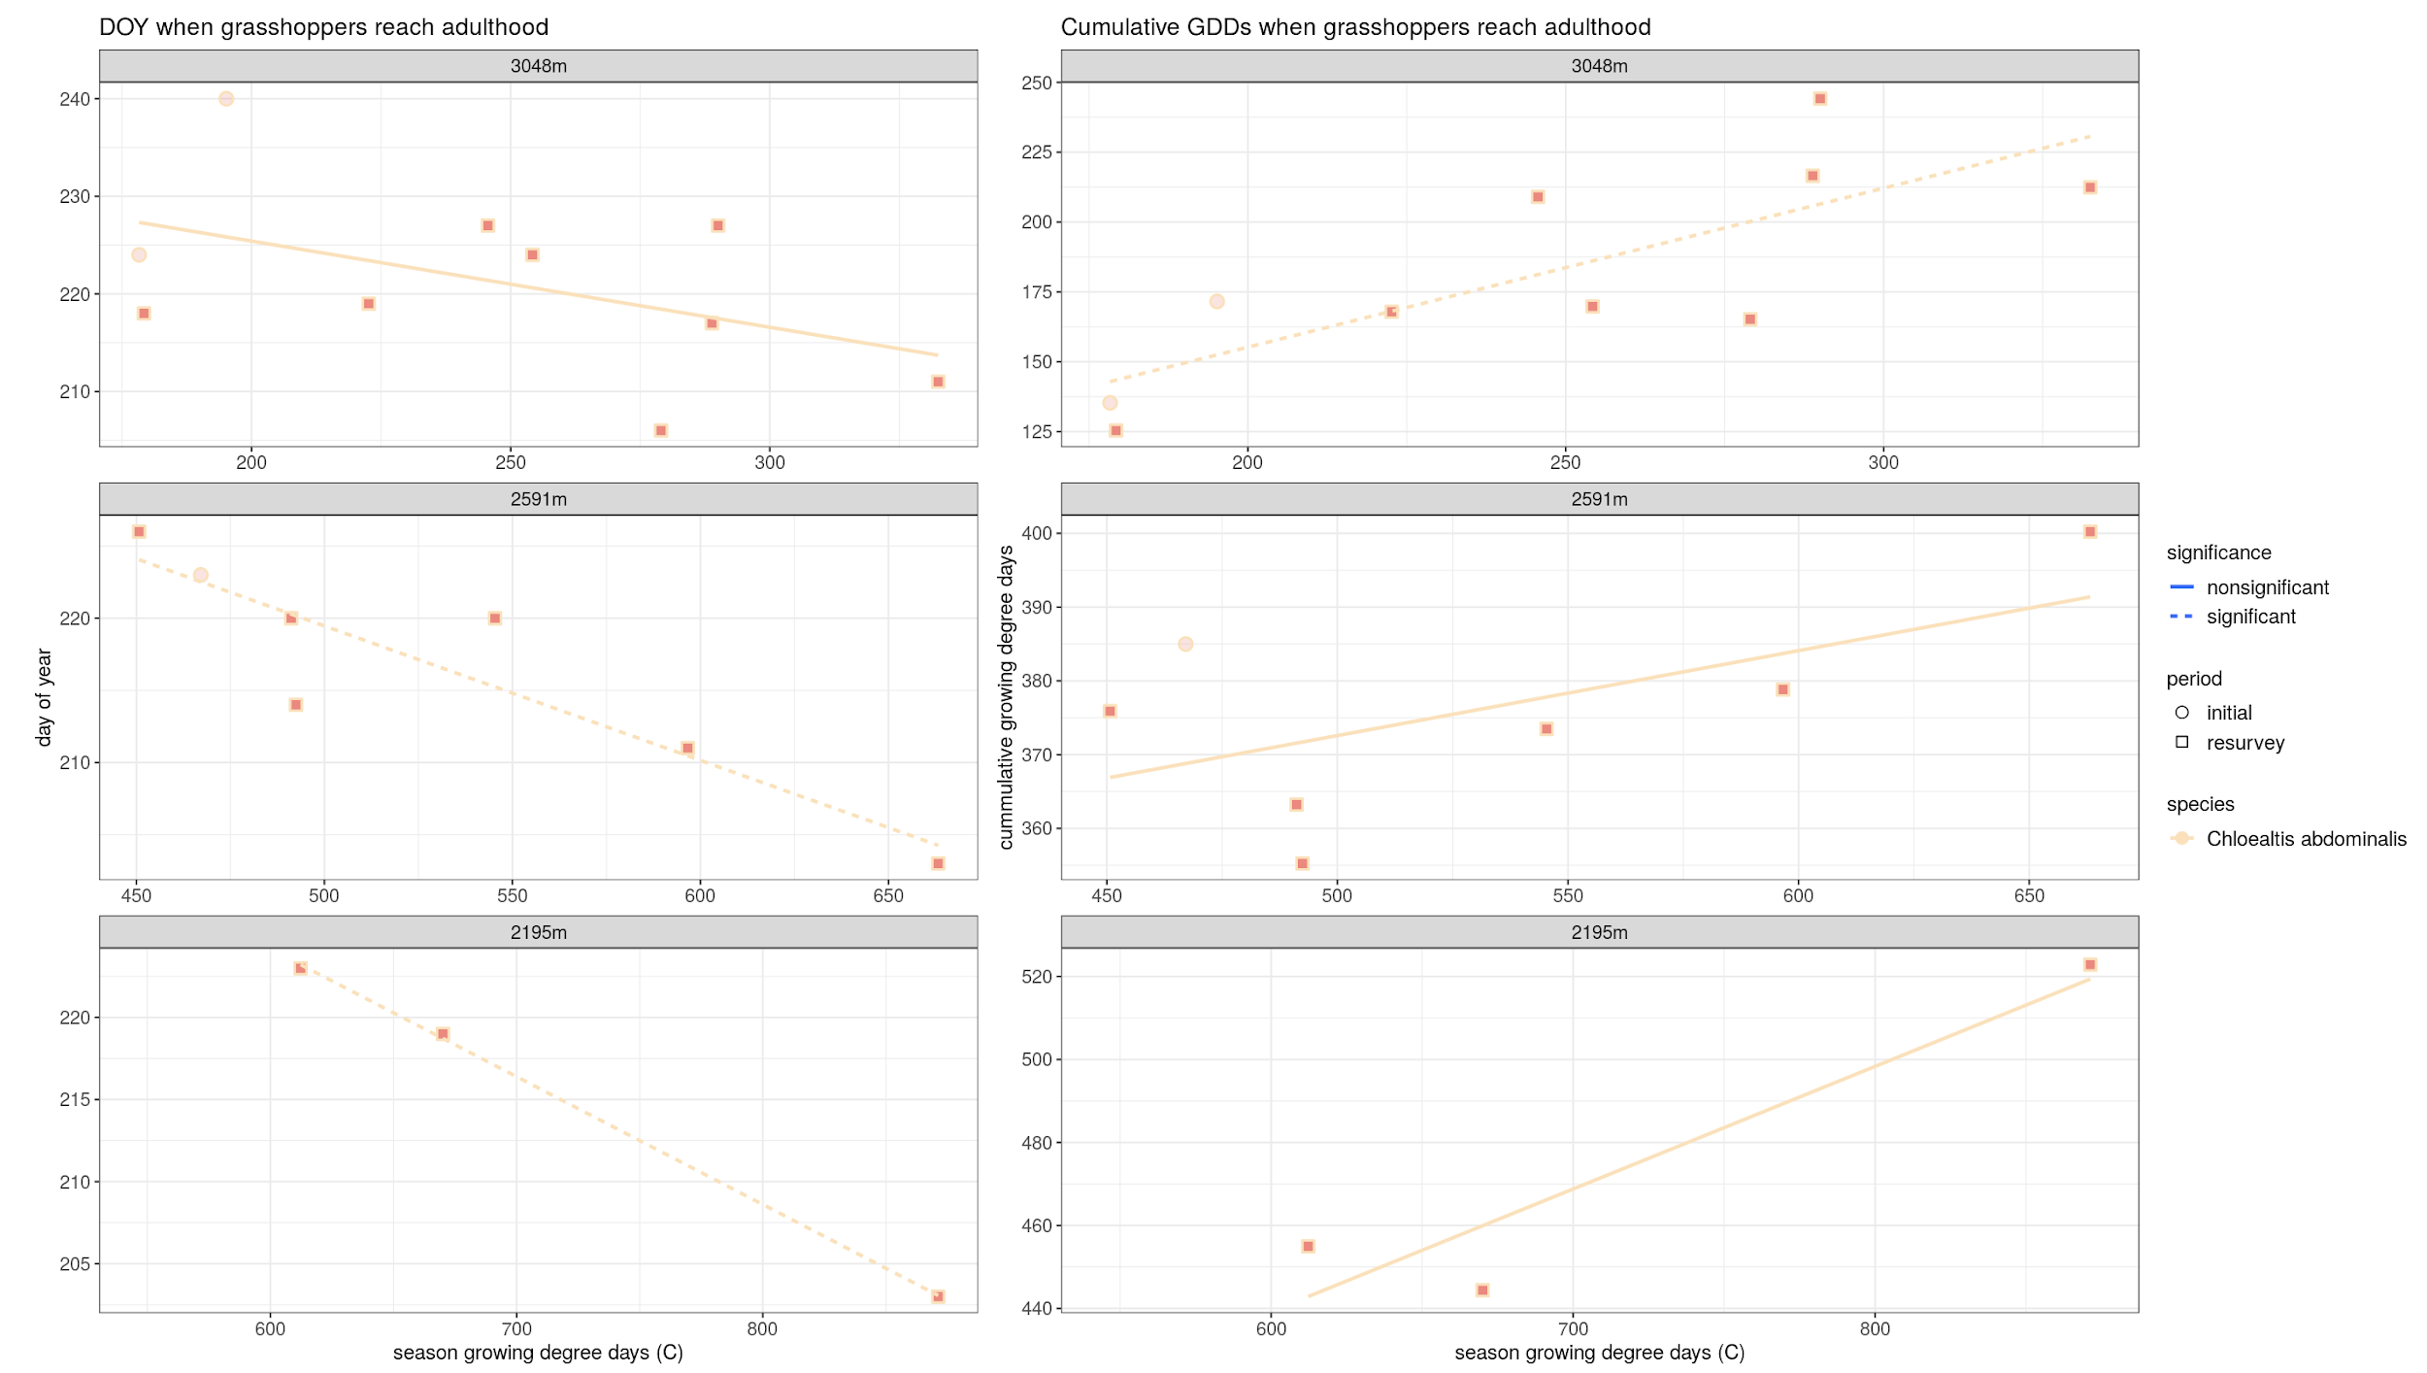

* 1. How does the amount of accumulated heat experienced by *C. abdominalis* when it reaches adulthood change with seasonal warmth?

The amount of accumulated heat it experiences increases with seasonal warmth.

* 1. Is this different at low vs. high elevations? Explain why this might be.

For this species, it seems that this is more pronounced at lower elevations. This might be due to a general abundance of GDDs at a lower elevation. Therefore, low-elevation grasshoppers may not follow warmer temperatures as closely as the more at risk high-elevation populations.